Tim Swass
Period 2
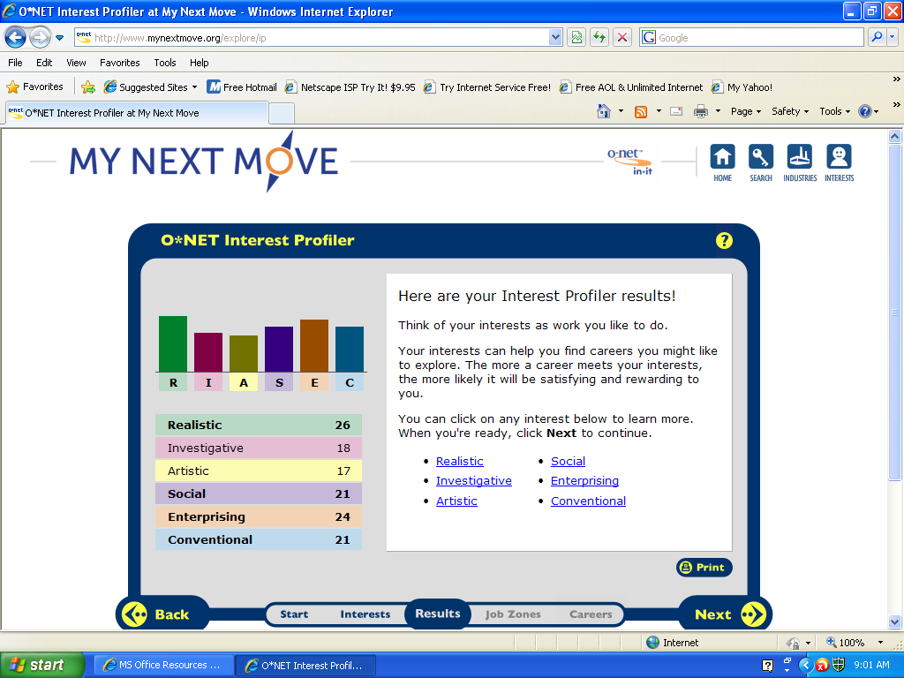
Yes realistic work field matches up with me because it is the exact kind of work I would like to do. Hands on problems and not working to closely with others. I like working with heavy machinery and being outside so that makes it a stronger reason why it matches up with me. Yes enterprising work field matches up with me because I like taking actions and going through with things rather than thinking about it. I like starting and carrying out projects. It also matches up with me because I can be a leader of a group and could be elected to an office. The social field does not really match up with me because I work better on my own then with others. The conventional work field matches up with me because I like working under a strong leader, and following routines. I also like working with clear rules. The conventional field does not match well with me because I am not very organized and don’t enjoy collecting books.
Military Officer Business Executive Lawyer Buyer
Police Officer Politician Judge
Coach Manager Geologist
Police Officer
HR1. What is the definition of each occupation that your group has chosen and the nature of the work? A law enforcer and protector.
HR2. What are some of the related occupational fields? Correctional Officer, Fire fighter, Detective.
HR3. Which personality type(s) is best suited to the occupations/jobs you have researched? Friendly and of good character but loyal and strong.
HR4. What kind of education, training and qualifications are required? A high school diploma and some work experience.
HR5. What technology skills are needed to be successful in the career/occupational fields you have explored?
RC1. What does each occupation pay, or what are the average earnings nationally and in this area of the country? Around 53,000$ a year.
RC2. What is the projected growth for this career field over the next 10 years? (i.e. will there be more or less jobs like this in the future?) Police work is expected to grow as much as any other jobs through 2018.
RC3. Please identify local or national organizations that would hire someone in each career field you have explored. State and local police.
ISC1. What are the working conditions or work environment for each job you or your group decided to research (such as work schedule, hours, exempt/salaried or non-exempt/hourly, etc.)? Usually a 40 hour week, work in any weather and must be ready on any notice.
ISC2. Are positions in this career field typically part of collective bargaining units (unions)? Yes police are in a union.
ISC3. What kind of opportunities for advancement are there for each career? (i.e. Is there a chance to get promoted, etc.?) Promoted to a higher rank on the Police force, also raise in salary and Awards.

Military Officer
HR1. What is the definition of each occupation that your group has chosen and the nature of the work? Armed Forces member.
HR2. What are some of the related occupational fields? Law Enforcement.
HR3. Which personality type(s) is best suited to the occupations/jobs you have researched? Respectful, and loyal.
HR4. What kind of education, training and qualifications are required? High School Diploma ,and college degree on some occasions.

HR5. What technology skills are needed to be successful in the career/occupational fields you have explored? Some people will need to have skills such as using gps, artillery technologies.

RC1. What does each occupation pay, or what are the average earnings nationally and in this area of the country? Salary can vary depending on years of service and rank.
RC2. What is the projected growth for this career field over the next 10 years? (i.e. will there be more or less jobs like this in the future?) Should grow as much as any other career field.

RC3. Please identify local or national organizations that would hire someone in each career field you have explored. National Guard, Army, Navy, Marines, Air force.

ISC1. What are the working conditions or work environment for each job you or your group decided to research (such as work schedule, hours, exempt/salaried or non-exempt/hourly, etc.)? Depending on if the soldier is in the reserves or real army, reserves are working every few weeks, full time soldiers work every day except when on vacation to be with family.

ISC2. Are positions in this career field typically part of collective bargaining units (unions)? No.
ISC3. What kind of opportunities for advancement are there for each career? (i.e. Is there a chance to get promoted, etc.?) Promotions in rank, awards and distinguished honors.

Lawyer
HR1. What is the definition of each occupation that your group has chosen and the nature of the work? Lawyers, also called attorneys, act as both advocates and advisors in our society. As advocates, they represent one of the parties in criminal and civil trials by presenting evidence and arguing in court to support their client.

HR2. What are some of the related occupational fields? Attorney.
HR3. Which personality type(s) is best suited to the occupations/jobs you have researched? Trustworthy , intelligent.
HR4. What kind of education, training and qualifications are required? 4 year college degree, 3 years of law school.

HR5. What technology skills are needed to be successful in the career/occupational fields you have explored?

RC1. What does each occupation pay, or what are the average earnings nationally and in this area of the country? Varies from around 40,000 to 100,000$.
RC2. What is the projected growth for this career field over the next 10 years? (i.e. will there be more or less jobs like this in the future?) 13% of growth out of all jobs in America until 2018.
RC3. Please identify local or national organizations that would hire someone in each career field you have explored. Government agencies.

ISC1. What are the working conditions or work environment for each job you or your group decided to research (such as work schedule, hours, exempt/salaried or non-exempt/hourly, etc.)? Most work done in offices, law libraries, and courtrooms.

ISC2. Are positions in this career field typically part of collective bargaining units (unions)? No.
ISC3. What kind of opportunities for advancement are there for each career? (i.e. Is there a chance to get promoted, etc.?) Possibility of raise in salary.

Judge
HR1. What is the definition of each occupation that your group has chosen and the nature of the work?
Judges are in charge of trials and make sure that they are fair. They resolve differences between lawyers. They read the law to decide what lawyers can and can't do.

HR2. What are some of the related occupational fields? Lawyers, Police & Detectives.
HR3. Which personality type(s) is best suited to the occupations/jobs you have researched? Determined & fair.
HR4. What kind of education, training and qualifications are required? Have to go to law school and serve as a lawyer.

HR5. What technology skills are needed to be successful in the career/occupational fields you have explored?

RC1. What does each occupation pay, or what are the average earnings nationally and in this area of the country? Judges have average yearly wages of $100,450.
RC2. What is the projected growth for this career field over the next 10 years? (i.e. will there be more or less jobs like this in the future?) This job field is expected to slowly decline in numbers.
RC3. Please identify local or national organizations that would hire someone in each career field you have explored. State and local governments.

ISC1. What are the working conditions or work environment for each job you or your group decided to research (such as work schedule, hours, exempt/salaried or non-exempt/hourly, etc.)? Work on the days they are needed in trials.

ISC2. Are positions in this career field typically part of collective bargaining units (unions)? No.
ISC3. What kind of opportunities for advancement are there for each career? (i.e. Is there a chance to get promoted, etc.?) Payment raise.

Politician
HR1. What is the definition of each occupation that your group has chosen and the nature of the work? Politicians run Federal, State, and local governments.

- HR2. What are some of the related occupational fields? High ranking officers in the military.

HR3. Which personality type(s) is best suited to the occupations/jobs you have researched? A committed person, wanting to help there country.
HR4. What kind of education, training and qualifications are required? Candidates for office usually must be a certain age. They must live in their area, and be a U.S. citizen.

HR5. What technology skills are needed to be successful in the career/occupational fields you have explored?

RC1. What does each occupation pay, or what are the average earnings nationally and in this area of the country? Politicians who are legislators have average yearly wages of $37,980.
RC2. What is the projected growth for this career field over the next 10 years? (i.e. will there be more or less jobs like this in the future?) Jobs for politicians are expected to show little or no change.
RC3. Please identify local or national organizations that would hire someone in each career field you have explored. State and local governments.

ISC1. What are the working conditions or work environment for each job you or your group decided to research (such as work schedule, hours, exempt/salaried or non-exempt/hourly, etc.)? Most politicians may work a 60 hour week.

ISC2. Are positions in this career field typically part of collective bargaining units (unions)? No.
ISC3. What kind of opportunities for advancement are there for each career? (i.e. Is there a chance to get promoted, etc.?) Possible salary raise.

Coach
HR1. What is the definition of each occupation that your group has chosen and the nature of the work? Coaches help people learn how to play a sport. They start by teaching them the basics, such as proper form and technique.

HR2. What are some of the related occupational fields? Professional athletes, Umpires.
HR3. Which personality type(s) is best suited to the occupations/jobs you have researched?
HR4. What kind of education, training and qualifications are required? People who are certified to teach academic subjects, like history or science, in addition to physical education should have the best chances for high school coaching jobs.

HR5. What technology skills are needed to be successful in the career/occupational fields you have explored?

RC1. What does each occupation pay, or what are the average earnings nationally and in this area of the country?
Coaches and scouts have average yearly wages of $35,580.

RC2. What is the projected growth for this career field over the next 10 years? (i.e. will there be more or less jobs like this in the future?) The number of jobs is expected to grow much faster than the average for all occupations.
RC3. Please identify local or national organizations that would hire someone in each career field you have explored. Professional baseball teams.

ISC1. What are the working conditions or work environment for each job you or your group decided to research (such as work schedule, hours, exempt/salaried or non-exempt/hourly, etc.)? Coaches that are full times usually work 40 hours a day during the sport season.

ISC2. Are positions in this career field typically part of collective bargaining units (unions)? No.
ISC3. What kind of opportunities for advancement are there for each career? (i.e. Is there a chance to get promoted, etc.?) Possible raise in salary.

Food service Manager
HR1. What is the definition of each occupation that your group has chosen and the nature of the work? Food service managers are responsible for the daily operations of restaurants and other establishments that prepare and serve meals and beverages to customers.

HR2. What are some of the related occupational fields? Sales worker supervisors.
HR3. Which personality type(s) is best suited to the occupations/jobs you have researched? Friendly, and happy person.
HR4. What kind of education, training and qualifications are required? Experience in the food services industry, whether as a cook, waiter or waitress, or counter attendant, is the most common training for food service managers.

HR5. What technology skills are needed to be successful in the career/occupational fields you have explored?

RC1. What does each occupation pay, or what are the average earnings nationally and in this area of the country? Annual wages of salaried food service managers are $46,320.

RC2. What is the projected growth for this career field over the next 10 years? (i.e. will there be more or less jobs like this in the future?) In the next ten years Managing jobs are expected to grow 5 % out of all jobs.

RC3. Please identify local or national organizations that would hire someone in each career field you have explored. Restaurants throughout the country.

ISC1. What are the working conditions or work environment for each job you or your group decided to research (such as work schedule, hours, exempt/salaried or non-exempt/hourly, etc.)? Many food service managers work long hours—12 to 15 per day, 50 or more per week, and sometimes 7 days a week.

ISC2. Are positions in this career field typically part of collective bargaining units (unions)?
ISC3. What kind of opportunities for advancement are there for each career? (i.e. Is there a chance to get promoted, etc.?) Salary Raise.

Business Executive
HR1. What is the definition of each occupation that your group has chosen and the nature of the work? All organizations have specific goals and objectives that they strive to meet. Top executives devise strategies and formulate policies to ensure that these goals and objectives are met.

HR2. What are some of the related occupational fields? Administrative services manager.
HR3. Which personality type(s) is best suited to the occupations/jobs you have researched? Intellegient, friendly.
HR4. What kind of education, training and qualifications are required? The formal education and experience required by top executives vary as extensively as their responsibilities do, but many of these workers have at least a bachelor's degree and considerable experience.

HR5. What technology skills are needed to be successful in the career/occupational fields you have explored?

RC1. What does each occupation pay, or what are the average earnings nationally and in this area of the country? Top executives are among the highest paid workers in the United States. However, salary levels vary substantially, depending on level of executive responsibility; length of service; and type, size, and location of the firm, organization, or government agency.

RC2. What is the projected growth for this career field over the next 10 years? (i.e. will there be more or less jobs like this in the future?) Employment of top executives—including chief executives and general and operations managers is expected to experience little to no change.

RC3. Please identify local or national organizations that would hire someone in each career field you have explored. Local or Government business’s.

ISC1. What are the working conditions or work environment for each job you or your group decided to research (such as work schedule, hours, exempt/salaried or non-exempt/hourly, etc.)? Every day of the week every month of the year.

ISC2. Are positions in this career field typically part of collective bargaining units (unions)?
ISC3. What kind of opportunities for advancement are there for each career? (i.e. Is there a chance to get promoted, etc.?) Advancement may be accelerated by participation in company training programs that impart a broader knowledge of company policy and operations.
Geologist
HR1. What is the definition of each occupation that your group has chosen and the nature of the work? Geoscientists and hydrologists study the composition, structure, and other physical aspects of the Earth, and the Earth's geologic past and present by using sophisticated instruments to analyze the composition of earth, rock, and water.

HR2. What are some of the related occupational fields? Physicists and astronomers.

HR3. Which personality type(s) is best suited to the occupations/jobs you have researched? A person that is interested in this type of work.
HR4. What kind of education, training and qualifications are required? A master's degree is the primary educational requirement for most positions. A Ph.D. is necessary for most research and college teaching positions.

HR5. What technology skills are needed to be successful in the career/occupational fields you have explored?

RC1. What does each occupation pay, or what are the average earnings nationally and in this area of the country? Annual wages of geoscientists are $79,160.

RC2. What is the projected growth for this career field over the next 10 years? (i.e. will there be more or less jobs like this in the future?) Employment growth of 18 percent is expected for geoscientists, which is faster than the average for all occupations.

RC3. Please identify local or national organizations that would hire someone in each career field you have explored. Government or local business’s.

ISC1. What are the working conditions or work environment for each job you or your group decided to research (such as work schedule, hours, exempt/salaried or non-exempt/hourly, etc.)? Spend most time in office but sometimes in field work.

ISC2. Are positions in this career field typically part of collective bargaining units (unions)?
ISC3. What kind of opportunities for advancement are there for each career? (i.e. Is there a chance to get promoted, etc.?) Eventually, some are promoted to project leader, program manager, or to a senior research position.

